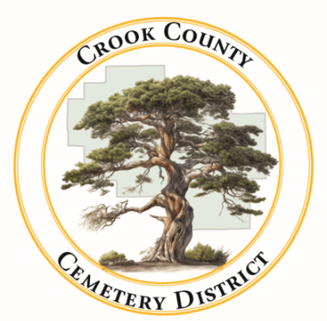 | Crook County Cemetery Improvement District  - September 17 2025 Board Meeting  1555 N. Main Street, Prineville Oregon
Date: October 14, 2025 Time: 1:00p.m.

In Attendance
Jamie Wood | Gary Bedortha | Annalisa Peer
Board Chair | Secretary | Administrative Assistant
Item
Meeting was called to order  The Budget Work session of the Crook County Cemetery District is called to order with quorum present. |  |  |  |  | Jamie Wood called meeting to order
- Consent Agenda
- Meeting minutes from August were tabled until next month
- Reports  - Financial  - Operations ~ Presented by Craig Yustat |  |  |  |  | Motion made by Jamie Wood to approve the bills  Board approved the Bills

Old Business
- Policy Development and Employee Handbook  After tabling the handbook discussion until board members had a chance to review the prepared handbook, board members were able to agree on the passing of the hand book. Jamie will distribute the handbooks to cemetery employees. |  |  |  |  | Motion made by Jamie Wood to pass the handbook  Motion passed
- Tree in Paulina
A down tree was reported in the Paulina cemetery. An old juniper tree rotted and fell partially on a out building and a headstone. Neither object was damaged and the tree has been taken care of.
- Sprinklers
More work is being done to update the sprinklers and improve the system overall
- Website
Annalisa was granted access to the website so she will be taking over that responsibility
- Grants
Grants for security upgrades and facility upgrades are being worked on. Due in November
- Howard Cemetery Update
A wildfire burned close to the Howard cemetery last month. It was reported that the fire did not reach the boundary of the cemetery and that there is no risk of trees falling in the cemetery. Another check will be done soon to verify.

New Business
- Two Board Reviews Approaching
  - Fall site inspection- follow up to last years inspection
  - 1 year employment review for Craig Yustat

Both will be scheduled with Craig in the near future
- Board member comments
  - Annalisa attended the Fall Cemetery Association Conference. She reported on some of the classes she took including ways to prepare for a state board review.

Adjournment at 1:30 pm

